Rainfall Prediction: Accuracy Enhancement Using Machine Learning and Forecasting Techniques

Abstract:
The paper is focused to provide the insights of climate to the clients from various businesses, e.g. agriculturists, researchers etc., to comprehend the significance of changes in climate and atmosphere parameters like precipitation, temperature, humidity etc. Precipitation estimate is one of the critical investigations in field of meteorological research. In order to predict precipitation, an endeavour is made to a couple of factual procedures and machine learning techniques to forecast and estimate meteorological parameters. For experimentation purpose daily observations were considered. The accuracy assessment of forecasting model experimentation is done using validation of results with ground truth. The experimentation demonstrates that for forecasting meteorological parameters ARIMA and Neural Network works best, and best classification accuracy in comparison to other machine learning algorithms for forecasting precipitation for next season was given by Random Forest model.
Keywords—Precipitation, ARIMA, SVM, Decision Tree, Holt Winter, Machine Learning, Random Forest

Table of contents
Chapter I. Introduction
1.1 Basic Preliminaries
Chapter II. Literature Survey
Chapter III. Proposed Method
Chapter IV. Hardware and Software Requirements
Performance Analysis
PERFORMANCE EVAULUTION
- DATASET SELECTION
- METRICS
Chapter V. RESULT
CONCLUSION
REFERENCES
APPENDIX
  - Python
  - Python GUI (Tkinter)
  - Libraries Used

List of Figures
Fig.3.1. Flow chart for proposed method
Fig.6.1.Upload Rainfall dataset
Fig.6.2. Select and upload Rainfall.csv
Fig. 6.3.Pre-process dataset
Fig. 6.4 Dataset contains records
Fig.6.5.SVM accuracy and RMSE values
Fig.6.6. Accuracy 98% and performance of Random forest
Fig.6.7. Accuracy 100 % and performance of Random forest
Fig.6.8.Performance of neural network
Fig.6.9 Accuracy 95% and performance of KNN
Fig.6.10. Accuracy graph

CHAPTER I
INTRODUCTION
In India, where the majority of agribusiness is dependent on precipitation as its standard wellspring of water, the time and measure of precipitation hold high importance and can impact the entire economy of the nation. Climate plays a vital role in our everyday life. From the earliest starting point of the human development, we are occupied with thinking about climatic changes. Weather forecasting is one of the most challenging issues seen by the world, in a most recent couple of century in the field of science and technology. Prediction is the phenomena of knowing what may happen to a system in the near future. Present weather observations are obtained by ground-based instruments and from the satellite through remote sensing. As India's economy significantly depends on horticulture, precipitation plays an important part.
The monthly climatic changes using spatiotemporal mining is being analyzed and the variability in seasonal rainfall using the IMD data with many rain gauge station information is done by K. Chowdari in[5][1]. Cluster analysis technique is also performed using no. of rainy days and rainfall as the input variable. L. Ingsrisawang in[11] has done a comparative study for rainfall prediction using different machine learning techniques on the north-eastern part of Thailand. The paper shows that, how the feature selection can be used to find the correlation between other weather parameter and the rainfall, the paper also shows the same day, next day, and next 2-day classification using ANN, SVM, KNN. Thai meteorological department (TMD) data is used for experimental purpose.
Attributes like temperature, humidity, pressure, wind, rain occurrence are used as input to the model. In [15] S.N Kohail has used daily historical data of the Gaza city and outlier analysis, prediction, classification, and clustering is done for temperature prediction. The paper shows the temperature prediction and classification for the Gaza city using many machine learning techniques; it also does outlier detection and clustering. Daily relative humidity, average temperature, wind speed with direction, time of highest speed and rainfall is used as an input parameter in the study.
Onset monsoon for the Indian sub-continent is predicted based on features extracted from the satellite image using data mining methods. KNN with euclidean distance is used for sea surface temperature (SST), cloud top temperature (CTT), cloud density, water vapour attributes were used. It predicts the onset monsoon in advance 10-30 days is proposed in[13]. Rainfall classification using supervised learning in Quest (SLIQ), and decision tree method with different Gini index is performed in[18]. Dew point, temperature, pressure, humidity, wind speed were used as an input parameter. Petre in [17](2008) proposed an approach that uses decision tree method with CART algorithm using data from meteorological department Hong Kong.
They have used year, month, average pressure, relative humidity, cloud quantity, precipitation, average temperature as an input parameter. The work is explained by S.-Y. Ji in[12] uses decision tree with CART and C4.5 algorithm with temperature, wind direction, wind speed, wind gust, outdoor humidity, evaporation, solar radiation, dew point, cloud cover, air density, vapour pressure, pressure altitude as a parameter. The proposed method predicts rain and it is classified into three categories in hourly rain 0.0 to 0.5 mm as level 1, 0.5 to 2.0 mm as level 2, > 2.0mm as level 3. A comparative study of data mining techniques is being done using historical weather data set.
Analysis of different machine learning techniques for regression as well as for the classification, paper shows that KNN performs better for classification and Naive Bayes performs better for regression [2]. Forecasting monthly rainfall for the Assam region using multiple linear regression is performed with the help of 6 years data gathered from regional meteorological center Guwahati[6]. Using Nigerian Meteorological Agency data paper individually predict the min temp, max temp, evaporation, rainfall and radiation using ANN and decision tree, error in rainfall is very high compared to other parameters prediction error in [14]. In [19] the comparison of several machine learning algorithms like ANN, Multiplicative Additive Regression Spline (MARS), radial basis SVM is done to forecast average daily and monthly rainfall of the Fukuoka city Japan.
Rainfall forecasting using neural network through the satellite image is attempted in [14] with parameters like relative humidity, pressure, temperature, precipitate water, wind speed. Daily rainfall prediction over Dhaka station in Bangladesh using markov chain model and logistic regression is performed with the help of no of rainy days, no of dry days and rainfall as a parameter in [8][16]. We have observed that most of the papers [5][2][19][14][9][3] claiming higher accuracy have classified rainfall into three or less than three categories or have estimated rainfall using machine learning techniques but have not done rainfall forecasting using machine learning techniques, few of them have used few meteorological parameters for the estimation of the rainfall.
The papers which are forecasting rainfall have used the regression techniques and forecasting techniques have less accuracy. We have proposed a model to predict the rainfall using a fusion of forecasting and machine learning techniques. Prediction of rainfall depends on various other parameters along with temperature. Classifying the rainfall gives us the good classification accuracy but our ultimate goal is to predict the rainfall using the other forecasted parameters. In this study objective is not only to correctly classify rainfall but also correctly predict the rainfall using various forecasted parameters.
Our work is focused on understanding the effects of different meteorological parameters in rainfall prediction along with an exploration of approaches which were used for forecasting rainfall, machine learning, and their limitation. The proposed model predicts the rainfall for the next season using machine learning and forecasting techniques. Our contribution to this problem is to analyse the accuracy of different machine learning and forecasting techniques to predicts precipitation for next season.
The rest of paper is organized as follows: Section II elaborates the methods used. The proposed architecture is explained in Section III. Section IV presents the source of data information; parameters used with their dates are mentioned along with comparison of the results of the different machine learning and forecasting methods. This section also includes the final classification accuracy of the rainfall. We have concluded our work in Section V with future scope.
Since long it has been observed and experienced that the weather prediction is becoming very crucial. The success of prediction solely depends upon the exactness of the model. There are many experiments carried out to develop appropriate model using various techniques. The India Meteorological Department (IMD) has developed different models like Parametric, Power Regression, Multiple Regression, Dynamic Stochastic Transfer, Power Transfer, Principal Component Regression and Neural Network models for issuing these long-range seasonal forecasts.
A number of different Neural Network architectures and machine learning methods have been applied to the time series prediction problem with varying degrees of success. However, there still exists a need for satisfactory guidelines when choosing a model size for a particular prediction problem. In this paper we propose the methodology for weather forecasting by using the historical data of the weather. The objective of model development is to minimize the cost function and error which is the difference between desired and calculated values.
In recent years, long range monsoon rainfall forecast based on the power regression model has been found to be comparatively more accurate. Therefore the result of the power regression model has been given weightage in this forecast. Some areas in India have high humidity while some are dry. In this paper, we are using the techniques of machine learning algorithms namely k-Nearest Neighbours, Naive Bayes and Multi-layer perceptron. The multi-layer perceptron is a technique of Artificial Neural Network. The fields of neural network approach are pattern recognition, system modeling and prediction. System-modeling capability of neural network approach is important.
There are some advantages to modeling, design, problem solving and approximation of the mapping. By using neural network, it is possible
- to work without the knowledge of the physical process, assuming the internal parameters or boundary conditions,
- to train neural network itself by using massive amount of the data, and
- To use a complex nonlinear mapping, such as precipitation phenomena.
The process of data organization into categories such that data objects of same category are more similar and data objects from different groups are not same is called as classication. Classification algorithm works to assign each instance to a particular class such that classification error will be lowest. Hence it is used to extract models that accurately define important data classes within the given dataset. The techniques of classification divided into two parts namely - training and testing.
A change in the Climate is a noteworthy change in the statistical distribution of weather structures over periods from decades to thousands of years. The change may be a change in average weather state or the events surround by that average. (e.g. extreme weather events)[4]. the terms Climate change and global warming both are interchangeable but they refers to two different physical situations. Increase in the earth’s surface temperature or increase in the greenhouse gases results in global warming which is human caused warming, while changes in the global temperature both by natural and human caused over time is termed as climate change.
Climate can change because of some natural process like Milankovitch, solar , ocean cycles or because of Human activities like deforestation ,burning fossil fuels etc. Nowadays computers are playing vital role in handling weather and climate data and helps in generating the analytical reports on various climate parameters.
Actually we are living in the Data Age i.e., data in terms of terabytes or petabytes is dumping every day into computer networks, World Wide Web and other storage devices from different sources like business, society, science & engineering, medicine etc. Analyzing such data is an important need. Data Mining is a process of mining or extracting information or knowledge from huge quantity of data such as databases, data warehouses ,transactional etc., and also known as Knowledge Discovery in Databases (KDD). The KD process involves Data - cleaning, integration, selection, transformation, mining, pattern evaluation and Knowledge presentation.
Descriptive and predictive data mining tasks are used which are very flexible, efficient and powerful for analysis compared to statistical methods.[4]. Classification & clustering are commonly employed techniques in data mining. k – Nearest Neighbour (k-NN) is most often used algorithm for classification which is used to classify huge historical data into a specific time span [5]. In this work both Data mining Techniques i.e., Classification & Clustering were employed to analyse data collected from different India station over a period of 53 years (1951-2003) in order to develop classification rules for weather parameters over the study period using available historical data.
Classification is also known as Machine learning which is DM technique used to forecast group membership for data objects using classifiers and Clustering is DM technique which is used to group abstract instances into resembling instance classes. The changes in Min and Max - temperature, rainfall, wind speed and Evaporation are the major targets for the forecast.
The increasing availability of climate data during the last decades (observational records, radar and satellite maps, observations from ship and aircraft ,proxy data, etc.) makes it important to find an effective and accurate tools to analyze and extract hidden knowledge from this huge data. Meteorological data mining is a form of Data mining concerned with finding hidden patterns inside largely available meteorological data, so that the information retrieved can be transformed into usable knowledge. Useful knowledge can play important role in understanding the climate variability and climate prediction.
In turn, this understanding can be used to support many important sectors that are affected by climate like agriculture, vegetation, water resources and tourism. Weather forecasting has been one of the most scientifically and technologically challenging problems around the world in the last century[12]. This is due mainly to two factors: first, it’s used for many human activities and secondly, due to the opportunism created by the various technological advances that are directly related to this concrete research field, like the evolution of computation and the improvement in measurement systems [10].
To make an accurate prediction is one of the major challenges facing meteorologist all over the world. Since ancient times, weather prediction has been one of the most interesting and fascinating domain. Scientists have tried to forecast meteorological characteristics using a number of methods, some of these methods being more accurate than others [11]. Since the oldest human civilization, humans have attempted to predict the weather informally. Now, weather forecasting is made through the application of science and technology. It is made by collecting quantitative data about the current state of the atmosphere through weather station and interprets by meteorologist.[9]
Rainfall information is important for food production plan, water resource management and all activity plans in the nature. The occurrence of prolonged dry period or heavy rain at the critical stages of the growth and development may lead to significant reduce crop yield. Assam is an agricultural state and its economy is largely based upon crop productivity. Thus rainfall prediction becomes a significant factor in agricultural state like Assam [1] The weather forecasts are divided into the following categories.
• Now casting- in which the details about the current weather and forecasts up to a few hours ahead are given.
• Short range forecasts (1 to 3 days) –in which the weather (mainly rainfall) in each successive 24 hr intervals may be predicted upto 3 days. This forecast range is mainly concerned with the weather systems observed in the latest weather charts, although generation of new systems is also considered.
• Medium range forecasts (4 to 10 days) – Average weather conditions and the weather on each day may be prescribed with progressively lesser details and accuracy than that for short range forecasts.
• Long range /Extended Range forecasts (more than 10 days to a season). There is no rigid definition for Long Range Forecasting, which may range from a monthly to a seasonal forecast.
A wide range of rainfall forecast methods are employed in weather forecasting at regional and national levels. Fundamentally there are two approaches to predict Rainfall. They are Empirical and Dynamical Methods. The Empirical approach is based on analysis of past historical data of weather and its relationship to a variety of atmospheric variables over different parts of Assam. The most widely use empirical approaches used for climate prediction are Regression, artificial neural network, fuzzy logic and group method of data handling.[2]
The dynamical approach, predictions are generated by physical models based on system of equations that predict the future Rainfall. The forecasting of weather by computer using equations is known as numerical weather prediction. To predict the weather by numeric means, meteorologist has developed atmospheric models that approximate the change in temperature, pressure etc. using mathematical equations. In our Project, Rainfall prediction is implemented with the use of empirical statistical technique. We use 6 years(2007-2012)datasets such as minimum temperature, maximum temperature ,pressure, wind direction ,relative humidity etc. and is going to perform prediction of Rainfall using Multiple Linear Regression(MLR) .
This model is going to forecasts monthly rainfall amount in summer monsoon season (in mm).The resulted rainfall amounts are intended to help farmers in making decision concerning with their crop. Since rainfall is one of the causes of possible calamities like floods and typhoons, predicting the occurrence of rainfall will help us to be prepared for these possible calamities. The basic procedures involve are firstly identifying an initial model, secondly repeatedly changing the model by removing a predictor variable based on a criteria and then terminating the process when we get a model which fits the data well.
In India, in which the majority of agribusiness is depending on precipitation as its preferred wellspring of water, the time and degree of precipitation maintain excessive significance and may affect the whole financial system of the state. Climate performs a crucial function in our regular existence. From the earliest starting point of the human improvement, we are inquisitive about considering climatic changes. Climate forecasting is one of the maximum challenging troubles visible by means of the arena, in a maximum recent couple of century within the area of technological know-how and generation.
Prediction is the phenomena of understanding what may also appear to a device inside the near destiny. Gift climate observations are obtained with the aid of ground-primarily based devices and from the satellite through far off sensing. As India's financial system extensively relies upon on horticulture, precipitation plays an vital part. The month-to-month climatic modifications using spatiotemporal mining is being analysed and the variety in seasonal rainfall the use of the IMD records with many rain gauge station information is achieved by using k. Chowdari in[5][1]. Cluster Cluster analysis method is also done the usage of no. Of wet days and rainfall as the enter variable.
L. Ingsrisawang in[11] has achieved a comparative examine for rainfall prediction the use of diff- erent machine gaining knowledge of techniques at the north-jap part of Thailand. The paper shows that, how the characteristic selection may be used to locate the correlation among different weather parameter and the rainfall, the paper additionally indicates the same day, next day, and next 2-day category the use of ANN, SVM, KNN. Thai meteorological branch (TMD) facts are used for experimental cause. Attributes like temperature, humidity, stress, wind, rain occurrence are used as input to the model. In [15] S.N Kohail has used each day historic records of the Gaza metropolis and outlier evaluation, prediction, type, and clustering is finished for temperature prediction.
The paper indicates the temperature prediction and class for the Gaza metropolis the use of many device getting to know strategies, it additionally does outlier detection and clustering. Day by day relative humidity, common temperature, wind speed with course, time of maximum pace and rainfall is used as an input parameter inside the examine. Onset monsoon for the Indian sub-continent is expected based totally on features extracted from the satellite image using statistics mining techniques. KNN with euclidean distance is used for sea floor temperature (SST), cloud top temperature (CTT), cloud density, water vapour attributes had been used. It predicts the onset monsoon in advance 10-30 days is proposed in [13].
Rainfall classification the usage of supervised getting to know in Quest (SLIQ), and selection tree method with exceptional Gini index is done in[18]. Dew point, temperature, pressure, humidity, wind pace have been used as an enter parameter. Petre in [17](2008) proposed an technique that makes use of choice tree approach with CART algorithm the usage of statistics from meteorological branch Hong Kong. They have used yr, month, common stress, relative humidity, cloud amount, precipitation, average temperature as an input parameter.
The paintings are defined by way of S.-Y. Ji in [12] makes use of decision tree with CART and C4.Five algorithm with temperature, wind path, wind pace, wind gust, Out of doors humidity, evaporation, sun radiation, dew factor, cloud cover, air density, vapour pressure, stress altitude as a parameter. The proposed method predicts rain and it's miles classified into 3 classes in hourly rain 0.Zero to 0.Five mm as degree 1, 0.5 to two. Zero mm as degree 2, > 2.0mm as stage 3. A comparative observe of statistics mining techniques is being executed using ancient climate statistics set. Evaluation of different device learning strategies for regression in addition to for the class, paper indicates that KNN performs better for type and Naive Bayes plays higher for regression [2].
Forecasting monthly rainfall for the Assam region the usage of a couple of linear regression is completed with the assist of 6 years records accrued from regional meteorological middle Guwahati[6]. The use of Nigerian Meteorological agency statistics paper in my opinion expect the min temp, max temp, evaporation, rainfall and radiation the use of ANN and selection tree, error in rainfall may be very high compared to different parameters prediction error in [14]. In [19] the comparison of several system gaining knowledge of algorithms like ANN, Multiplicative Additive Regression Spline (MARS), radial foundation SVM is performed to forecast average day by day and month-to-month rainfall of the Fukuoka town Japan.
Rainfall forecasting the use of neural community via the satellite tv for pc photo is tried in [14] with parameters like relative humidity, pressure, temperature, precipitate water, wind velocity. Day by day rainfall prediction over Dhaka station in Bangladesh using markov chain model and logistic regression is achieved with the help of no of wet days, no of dry days and rainfall as a parameter in [8][16]. We've located that most of the papers [5][2][19][14][9][3] claiming higher accuracy have categorized rainfall into 3 or much less than three classes or have expected rainfall the usage of machine learning strategies but have now not carried out rainfall forecasting the usage of system studying techniques, few of them have used few meteorological parameters for the estimation of the rainfall.
The papers which might be forecasting rainfall have used the regression techniques and forecasting strategies have less accuracy. We've got proposed a model to are expecting the rainfall the usage of a fusion of forecasting and machine getting to know techniques. Prediction of rainfall depends on numerous different parameters together with temperature. Classifying the rainfall gives us the good class accuracy however our remaining goal is to predict the rainfall the usage of the other forecasted parameters.
On this look at objective is not only to correctly classify rainfall but additionally efficiently expect the rainfall the use of various forecasted parameters. Our work is targeted on know-how the outcomes of different meteorological parameters in rainfall prediction together with an exploration of procedures which had been used for forecasting rainfall, device getting to know, and their obstacle. The proposed version predicts the rainfall for the following season the use of machine learning and forecasting strategies. Our contribution to this problem is to analyse the accuracy of various device mastering and forecasting techniques to predict precipitation.
Bangladesh is an agriculture-based country where about 80% of its about 160 million people are directly or indirectly engaged in a wide range of agricultural activities. Rainfall is the most important natural factor that determines the agricultural production in Bangladesh. The variability of rainfall and the pattern of extreme high or low precipitation are very important for the agriculture as well as the economy of the country. It is well established that the rainfall is changing on both the global and the regional scales due to global warming [1-3]. The implications of these changes are particularly significant for Bangladesh where hydrological disasters of one kind or another is a common phenomenon [4, 5].
Information on rainfall probabilities is vital for the design of water supply and supplemental irrigation schemes and the evaluation of alternative cropping and of soil water management plans. Such information can also be beneficial in determining the best adapted plant species and the optimum time of seeding to reestablish vegetation on deteriorated rangelands. Although rather long rainfall records are frequently available in many countries, little use is made of this information because of the unwieldly nature of the records. Markov chain is generally recognized as a simple and effective description of the rainfall occurrence. The amount and pattern of rainfall are among the most important weather characteristics and they affect agriculture profoundly.
In addition to their direct effects on water balance in soil, they are strongly related to other weather variables such as solar radiation, temperature, and humidity, which are also important factors affecting the growth and development of crops, pests, diseases and weeds. However, rainfall data form an essential input into many climatologic studies for agriculture, wherein considerable research focused on rainfall analysis and modeling [6]. “Persistence” means that tomorrow’s weather will be the same as todays. Based on this assumption the test of dependence of today’s state of rain on the yesterday’s or the day before yesterday’s state of rain grew to high importance.
A number of comprehensive and thorough research works have so far been conducted on rainfall but people are still scrutinizing ins and outs of meteorological data (specially rainfall) from different vantage points. The sequence of wet and dry spells for Rthamsted experimental station, Harpendeen were studied for two five years periods 1938 to 1942 and 1943 to 1947, where it is shown that the frequency distributions of dry spells follow nearly a logarithmic series [7]. The sequences in daily rainfall occurrences at Tel Aviv for 27 mid-winter (December-February) from 1929-1949 were studied and were found that the Markov chain of first order is well enough to describe the dependency of data.
They also found that the wet spell and dry spell follow geometric distribution [8,9]. The determination of the order of an ergodic Markov chain with a finite number of states using the method of Akaike’s Information Criterion (AIC) were discussed and applied the method to sequences of wet and dry days observed at Manchester and Liverpool, England [10]. The daily rainfall data at Samara, Nigeria during 1928 to 1978 was analyzed and the result shows that the first order Markov chain and gamma models provide a good fit to the precipitation data [11,12]. The start of the rains in West Africa for period 1943 to 1965 was examined and the start of the rain was defined as the first occurrence of a specified amount of rain within two successive days [13].
The probability distribution of seasonal rainfall data at Pabna station for the period 1902-1952 was analysed and the result shown that the seasonal and monthly totals for the rainy season follow a normal distribution [14]. The daily, monthly, seasonal rainfall data of rainy season for five selected stations of Bangladesh for the period between 1966 and 1986 was studied to identify the impact of rainfall on agriculture [15]. The pattern of rainfall for-rainy season of Sylhet area, Bangladesh for the period between 1974 to 1984 was also studied to examine the overall distribution of rainfall in the study area [16].
The trends of regional variations and periodicities of annual rainfall in Bangladesh for 32 years between 1947 and 1979 at 30 meteorological stations were studied and the results shown that the yearly rainfall amounts for most of the stations follow a normal distribution [17]. The pattern of rainfall for selected areas of Bangladesh on the basis of first order Markov chain for the period between 1966 and 1986 were also examined and found that the daily rainfall occurrences during rainy season follow [8,9] models [18]. Impacts of the patterns of rainfall on agriculture for Bangladesh employing the daily rainfall occurrences of rainy season for the period 1966 to 1986 were identified.
It was found that the first planting dates of Aus paddy follow Pearson type-1 model and Gaussian model for some areas [19]. The pattern of rainfall for separate transition probabilities of Markov chain, cases of stationary and non-stationary rainfall, covariate dependent transition probabilities of Markov model for rainfall occurrences for five meteorological stations of Bangladesh for the period 1964 to 1990 was also studied [20]. Also a case study on the probability distribution of both dry and wet spell for all seasons in Bangladesh in six divisional stations on the basis of 50 years of rainfall data were fitted [21].
Meanwhile, a case study reported that the first order of the Markov chain model found to fit the observed data in Italy successfully. The model based on the assumption that there is a dependency of the daily rainfall occurrence to that of the previous day [22]. Rainfall is the principal phenomenon driving many hydrological extremes such as floods, droughts, landslides, debris and mud-flows; its analysis and modeling are typical problems in applied hydrometeorology. Rainfall exhibits a strong variability in time and space. Hence its stochastic modeling is not an easy task [23].
The development of a rainfall occurrence model is increasingly in demand, not only for data-generation purposes, but also to provide some useful information in various applications, including water resource management, hydrological, and agricultural sectors. Identifying the appropriate model of daily rainfall occurrence, particularly on the distribution of dry (wet) spells, is very important as almost all of the climate variables are dependent on the rainfall events [24]. The information on weather’s wet and dry behaviour has vital importance to all allied fields like insurance, agriculture, industry etc.
Once the rainfall process is adequately and appropriately modelled, the model can then be used in agricultural planning, may be able to aid in draught, soil erosion and flood predictions, impact of climate change studies, crop growth studies and other important fields. The analysis of extreme yearly rainfall shows that Markov Chain approach provides one alternative of modelling future variation in rainfall. The study shows only with the rainfall occurrence processes, and, more specifically, with modelling daily rainfall occurrences (a day is wet or dry) and the amount of rainfall for wet days.
Hydrological and crop models usually require daily precipitation time series as input. To evaluate the sensitivity of these models to long-term changes in the precipitation regime an ensemble of input data sets are needed. The observed sequences provide only one realization of the weather process. To evaluate the range of results that may be obtained with other statistically equivalent series it is desirable to generate synthetic sequences of precipitation data based on the stochastic structure of the meteorological process. The climate of Bangladesh is characterized by uneven distribution of rainfall over seasons and also over regions.
Time series analysis of rainfall, has significant importance not only on cultivation but also on the crop calendar adjustment. An in-depth knowledge about the time series and logistic regression modeling on meteorological events (rainfall, humidity, minimum temperature and sea level pressure) has notable policy impact for agriculturists to develop effective cultivation system that will maximize the yield of crops. This study has concerned with the test of second order Markov chain at best. An attempt has been made to fit the logistic regression considering rainfall of current day as a dependent dichotomous variable on the independent dichotomous variables of yesterday and the day before yesterday’s rain.
The northeastern part of Thailand is an arid region with varied rainfall. To enhance the precipitation in this area, a number of cloud seeding operations have been conducted by the Royal Rain Making Project. Since there is no assurance for the success of cloud seeding operations, it is important to determine or forecast the success rate before any operations are conducted. Several climate factors, precipitation records and prediction results from the cloud models such as the Great Plains Cumulus Model (GPCM) are normally used in making the decision on whether the cloud seeding operation will be launched or not [7].
However, rainfall estimates are principal to evaluate the effectiveness of cloud seeding programs. Traditionally, rainfall estimates have been mainly derived and forecasted from numerical modeling with both radar and ground observations [2,6, 9]. As an alternative, this research presents the methodology from machine learning approaches to short-term rainfall forecasting. The goals of this paper are to present the methodology from machine learning approaches to short-term rainfall forecasting, including (1) how feature selection can be used to identify the relationships between rainfall occurrences and other weather conditions and (2) what models can be simply developed and deployed for predicting the accurate rainfall estimates to support the decisions in seeding operations.
Accurate rainfall prediction has a potential benefit of preventing causalities and damages caused by natural disasters. Also, the rainfall prediction has benefits of managing water resources effectively [9]. Under the certain circumstances such as flood and drought, highly accurate rainfall prediction is useful for agricultural management and disaster prevention. Thus, numerous computational approaches have been proposed to predict rainfall accurately. Since it is important to reveal any unknown, but important factors for rainfall prediction, numerous rainfall prediction methods have been proposed. However, most of the methods have performance limitations because of the existence of wide range of variations in data and limited amounts of data.
To perform an accurate rainfall prediction, several approaches have been proposed by using statistical approaches [3, 16], stochastic method [1], and neural networks [6, 8, 11, 17, and 21]. Georgakakos and Bras [5] suggested a physical prediction model to measure rainfall using real-time flood forecasting method. Cheon [4] studied on heavy rainfall prediction using air temperature, dew-point, and pressure on the ground. Thyer et al. [20] studied annual rainfall measurements using the first order Markov Chain modeling. Although some of the approaches showed good performances in predicting rainfall, most approaches do not provide any transparent reasons behind predicted outcomes.
Therefore, designing a computer-aided rule-based rainfall prediction with providing explicit reasons behind the outcomes is important for increasing the performance of rainfall estimation. In addition, it can help us understand underlying patterns in weather data. In this paper, we design a computer-aided rule-based rainfall prediction model to estimate hourly rainfall correctly. This prediction model predicts hourly rainfall by revealing hidden, but important patterns from input data and identifying transparent reasons behind outcomes. The rest of the paper consists of three sections. First we discuss our approach including the description about the weather data that we used in our study. Then, we provide experimental result, and conclude with conclusion and future work.
A wide variety of rainfall forecast methods are available in India because India is an agricultural country and the success of agriculture depends of rainfall. There are mainly two approaches to predict rainfall. They are Empirical method and dynamical method. The empirical approach is based on analysis of historical data of the rainfall and its relationship to a variety of atmospheric variables. The most widely used empirical approaches used for climate prediction are regression, Artificial Neural Network (ANN), fuzzy logic and group method of data handling. In dynamical approach, predictions are generated by physical models based on systems of equations that predict the evolution of the global climate system in response to initial atmospheric conditions[1].
The objective is to analyze the four months rainfall data i.e. from June to September of a particular region for 9 years because these months are monsoon season for our state Kerala. This paper describes empirical method technique belonging to clustering and classification and approach. ANNs are used to implement these techniques. The artificial neural networks not only analyze the data but also learn from it for future predictions making them suitable for weather forecasting. Neural networks provide a methodology for solving many types of non-linear problems that are difficult to be solved through traditional techniques. Furthermore neural networks are capable of extracting the relationship between inputs and outputs of a process without the physics being explicitly provided.
Hence these characteristics of neural networks can be used for the prediction of the weather processes[2]. The input variables given are Temperature, Pressure, Relative humidity, Wind speed, Precipitable water. The technique used for rainfall prediction is classification. In this technique, rainfall values are clustered using subtractive clustering and three classes or states are identified as low, medium and heavy[3]. Data are at 2.5 deg Lat x 2.5 Lon resolution, means the globe is divided into 144 x 73 grids. A daily rainfall data in the period of January 2001 to December 2010 were downloaded from the official website of National Oceanic and Atmospheric Administration (NOAA) maintained by US Department of Commerce.
NOAA maintains NCEP/NCAR Reanalysis data. NCEP/NCAR Reanalysis data set is a continually updating gridded data set representing the state of the Earth's atmosphere, incorporating observations and numerical weather prediction model. Downloaded data are between 7.5N-10N Lat and 75E-77.5E Lon that roughly covers the Cochin region.
Prediction of rainfall is the essential problem to be solved. The variation in the rainfall is primarily attributed to its association with Humidity, Temperature, Pressure, Wind Speed and Dew Point etc. Several works have been done in this field over the past few decades. An accurate prediction of rainfall events can aid in accurate financial planning of the economy of nation. The unpredictable natural disasters like floods and droughts not only affected the economy of a country but also the lifestyle of people of the countryside.
Data mining is an influential approach which helps in extracting hidden information from huge databases and allows decisions to be taken on knowledge mining basis. This paper highlights Supervised Learning in Quest (SLIQ), decision tree algorithm using Gini Index in order to predict the precipitation with an accuracy of 72.3% and is completely based on the historical data. The decision tree is constructed and the classification rules are generated.
In the present article, an attempt is made to derive optimal data-driven machine learning methods for forecasting an average daily and monthly rainfall of the Fukuoka city in Japan. This comparative study is conducted concentrating on three aspects: modelling inputs, modelling methods and pre-processing techniques. A comparison between linear correlation analysis and average mutual information is made to find an optimal input technique. For the modelling of the rainfall, a novel hybrid multi-model method is proposed and compared withits constituent models. The models include the artificial neural network, multivariate adaptive regression splines, thek-nearest neighbour, and radial basis support vector regression.
Each of these methods is applied to model the daily and monthly rainfall, coupled with a pre-processing technique including moving average and principal component analysis. In the first stage of the hybrid method, sub-models from each of theabove methods are constructed with different parameter settings. In the second stage, the sub-models are ranked with avariable selection technique and the higher ranked models are selected based on the leave-one-out cross-validation error. The forecasting of the hybrid model is performed by the weighted combination of the finally selected models. Accurate forecasting of rainfall has been one of the most important issues in hydrological research because earlywarnings of severe weather can help prevent casualties and damages caused by natural disasters, if timely and accurately forecasted.
To construct a predictive systemfor accurate rainfall, forecasting is one of the greatest challenges to researchers from diverse fields such asweather data mining (Yanget al., 2007), environmental machine learning (Hong, 2008), operational hydrology(Li and Lai, 2004), and statistical forecasting (Puchetaet al., 2009). A common question in these problems I show one can analyse the past and use future prediction. The parameters that are required to predict rainfall are enormously complex and subtle even for a short term period.
Physical processes in rainfall are generally composed of a number of sub-processes. A accurate modelling of rainfall by a single global model is sometimes not possible (Solomatine and Ostfeld, 2008). To overcome this difficulty, the concept of modular modelling and combining different models has attracted more attention recently in rainfall forecasting. In modular models, several sub-processes are first identified, and then separate models (also called local or expert models) are established for each of them (Solomatine and Ostfeld, 2008).
So far, various modular models have been proposed, depending on soft or hard splitting of training data. Soft splitting means that the dataset can be overlapped, and the overall forecasting output is the weighted average of each local model (Shrestha and Solomatine, 2006; Wuet al., 2008).In the hard splitting, there is no overlap of data and the final forecasting output is derived explicitly from only one of the local models (Wuet al., 2008). The approach of combining several models is also known as ensemble modelling. The basic idea behind the ensemble model is to build several different models for the same process and to integrate them together (Xionget al., 2001; Abrahart and See, 2002; Kimet al.,2006; Baruqueet al., 2011; Siweket al., 2009; Zamanand Hirose, 2011).
A decision tree represents a decision support tool very often used because it is simple to understand and interpret. Classification and Regression Trees - CART - is a technique formed by a collection of rules based on values of certain variables in the modelling data set. This paper presents a small application of CART for whether prediction. It had been chosen the data collection registered over Hong Kong. The data was recorded between 2002 and 2005. To build the decision tree we used a free data mining software available under the GNU General Public License– Weka. Then, there are presented the decision tree, the results and the statistical information about the data used to generate the decision model. Since ancient times, weather prediction has been one of the most interesting and fascinating domain.
The scientists have been trying to forecast the meteorological characteristics using a large set of methods, some of them more accurate than others. Lately, there has been discovered that data mining, a method developed recently, can be successfully applied in this domain. Data mining is a process that uses a variety of data analysis tools to discover patterns and relationships in data that may be used to make valid predictions [1]. The most commonly used techniques in data mining are: artificial neural networks, genetic algorithms, rule induction, nearest neighbour method and memory-based reasoning, logistic regression, discriminant analysis and decision trees.

1.1 BASIC PRELIMINARIES
A. Machine learning methods for Regression Multiple Linear Regression: In multiple linear regressions [7], multiple in-dependent parameters are taken as an input and based on the best-fitted line dependent continuous variable is predicted. The relation between them is derived by equation:
Y=a*X+b*Z+c
Where Y =Dependent Variable, a,b =Regression Parameters X, Z=Independent Variable, c=Intercept Support Vector Regression: The support vector regression (SVR) [3] uses the same principles as the SVM for classification, with only a few minor differences. To minimize error, individualizing the hyper plane which maximizes the margin, keeping in mind that part of the error is tolerated in linear support vector regression. Prediction of the rainfall using other independent parameters (temperature, humidity, pressure, wind speed etc.) is attempted in many studies showing the comparison of different machine learning techniques and claiming the higher ac-curacy with categorizing rainfall in two to three categories, but most of them have not attempted the forecasting of rainfall for next season using machine learning techniques.
In Few papers forecasting of the rainfall as well as different weather parameters like temperature, relative humidity, number of rainy days etc. is attempted. The result shows forecasting rainfall individually gives less accurate result compared to other weather parameters. As forecasting rainfall individually using forecasting techniques gives less accuracy and prediction of rainfall with the help of different weather parameter using machine learning techniques gives higher accuracy it is necessary to design the fusion model.
Weather forecasting has been one of the most scientifically and technologically challenging problems around the world in the last century. This is due mainly to two factors: first, it’s used for many human activities and secondly, due to the opportunism created by the various technological advances that are directly related to this concrete research field, like the evolution of computation and the improvement in measurement systems [3]. To make an accurate prediction is one of the major challenges facing meteorologist all over the world. Since ancient times, weather prediction has been one of the most interesting and fascinating domain.
Scientists have tried to forecast meteorological characteristics using a number of methods, some of these methods being more accurate than others [5] . Weather forecasting entails predicting how the present state of the atmosphere will change. Present weather conditions are obtained by ground observations, observations from ships and aircraft, radiosondes, Doppler radar, and satellites. This information is sent to meteorological centers where the data are collected, analyzed, and made into a variety of charts, maps, and graphs. Modern high-speed computers transfer the many thousands of observations onto surface and upper-air maps.
Computers draw the lines on the maps with help from meteorologists, who correct for any errors. A final map is called an analysis. Computers not only draw the maps but predict how the maps will look sometime in the future. The forecasting of weather by computer is known as numerical weather prediction. To predict the weather by numerical means, meteorologists have developed atmospheric models that approximate the atmosphere by using mathematical equations to describe how atmospheric temperature, pressure, and moisture will change over time. The equations are programmed into a computer and data on the present atmospheric conditions are fed into the computer.
The computer solves the equations to determine how the different atmospheric variables will change over the next few minutes. The computer repeats this procedure again and again using the output from one cycle as the input for the next cycle. For some desired time in the future (12, 24, 36, 48, 72 or 120 hours), the computer prints its calculated information. It then analyzes the data, drawing the lines for the projected position of the various pressure systems. The final computer-drawn forecast chart is called a prognostic chart, or prog. A forecaster uses the progs as a guide to predicting the weather. There are many atmospheric models that represent the atmosphere, with each one interpreting the atmosphere in a slightly different way.
The forecaster learns the idiosyncrasies of each model and places more emphasis on the ones that do the best job of predicting a particular aspect of the weather. Weather forecasts made for 12 and 24 hours are typically quite accurate. Forecasts made for two and three days are usually good. Beyond about five days, forecast accuracy falls off rapidly [1] . Climate is the long-term effect of the sun's radiation on the rotating earth's varied surface and atmosphere. The Day-by-day variations in a given area constitute the weather, whereas climate is the longterm synthesis of such variations.
Weather is measured by thermometers, rain gauges, barometers, and other instruments, but the study of climate relies on statistics. Nowadays, such statistics are handled efficiently by computers. A simple, long-term summary of weather changes, however, is still not a true picture of climate. To obtain this requires the analysis of daily, monthly, and yearly patterns [6] . Climate change is a significant and lasting change in the statistical distribution of weather patterns over periods ranging from decades to millions of years. It may be a change in average weather conditions or the distribution of events around that average (e.g., more or fewer extreme weather events). The term is sometimes used to refer specifically to climate change caused by human activity, as opposed to changes in climate that may have resulted as part of Earth's natural processes.
Climate change today is synonymous with anthropogenic global warming. Within scientific journals, however, global warming refers to surface temperature increases, while climate change includes global warming and everything else that increasing greenhouse gas amounts will affect. Evidence for climatic change is taken from a variety of sources that can be used to reconstruct past climates. Reasonably complete global records of surface temperature are available beginning from the mid-late 19th century. For earlier periods, most of the evidence is indirect. Climatic changes are inferred from changes in proxies, indicators that reflect climate, such as vegetation, ice cores, dendrochronology, sea level change, and glacial geology [12] .
In 1988, the United Nations Environment Program and the World Meteorological Organization established the Intergovernmental Panel on Climate Change (IPCC) to assess the environmental, social, economic, and scientific information available on climate change. The IPCC Second Assessment Report, published in 1995, concluded that the earth’s average surface air temperature had increased by between 0.3 and 0.6 Celsius degrees (between 0.5 and 1.1 Fahrenheit degrees) in the past 100 years. Their report states that this warming would continue and that global average surface temperature will increase by between 1.0 and 3.5 Celsius degrees (between 1.8 and 6.3 Fahrenheit degrees) by the year 2100.
If this warming occurs, sea levels would rise by between 15 cm and 95 cm (6 in and 37 in) by the year 2100, with the most likely rise being 50 cm (20 in). Such a rise in sea level would have a damaging effect on coastal ecosystems. Other changes that would occur as a result of this warming would include a shift in the world’s wind and rainfall patterns. Many climate scientists believe that human activity is responsible for global warming. They attribute the main cause of global warming to the burning of fossil fuels, which increases the concentration of carbon dioxide (CO2) gas in the atmosphere. Carbon dioxide levels which are presently about 360 parts per million (ppm), have increased by 28 percent in the past century [1] .
The effects, or impacts, of climate change may be physical, ecological, social or economic. It is predicted that future climate changes will include further global warming (that is, an upward trend in global mean temperature), sea level rise, and a probable increase in the frequency of some extreme weather events[11] . Data mining, also called Knowledge Discovery in Databases (KDD), is the field of discovering novel and potentially useful information from large amounts of data [10] . In contrast to standard statistical methods, data mining techniques search for interesting information without demanding a priori hypotheses, the kind of patterns that can be discovered depend upon the data mining tasks employed.
By and large, there are two types of data mining tasks: descriptive data mining tasks that describe the general properties of the existing data and predictive data mining tasks that attempt to do predictions based on inference on available data. This techniques are often more powerful, flexible, and efficient for exploratory analysis than the statistical techniques [2] . The most commonly used techniques in data mining are: Artificial Neural Networks, Genetic Algorithms, Rule Induction, Nearest Neighbor method, Memory-Based Reasoning, Logistic Regression, Discriminant Analysis and Decision Trees. In this work both Artificial Neural Networks (ANN) and Decision Trees (DT) were used to analyze meteorological data gathered from the Ibadan synoptic airport station over the period of ten years (2000 - 2009), in-order to develop classification rules for the weather parameters over the study period and for the prediction of future weather conditions using available historical data.
The targets for the prediction are those weather changes that affect us daily like changes in minimum and maximum temperature, rainfall, evaporation and wind speed. An Artificial Neural Network (ANN) is an information processing paradigm that is inspired by the way biological nervous systems, such as the brain, process information. It is composed of a huge number of highly interconnected processing elements (neurons) working in unison to solve specific problems. ANNs, like people, learn by example. An ANN is configured for a particular application, such as pattern recognition or data classification, through a learning process. The artificial neuron is an information processing unit that is fundamental to the operation of a neural network. There are three basic elements of a neuron model.
The basic elements of neuron model with the help of a perceptron model, which are, (i) a set of synapses connecting links, each of which is characterized by a weight or strength of its own, (ii) an adder for summing the input signals weighted by the respective synapses of the neuron and (iii) an activation function for limiting the amplitude of the output of a neuron.

CHAPTER II
LITERATURE SURVEY
- Mithila Sompura Aakash Parmar, Kinjal Mistree. Machine learning techniques for rainfall prediction: A review. International Conference on Innovations in informa-tion Embedded and Communication Systems, 2017.
Heavy rainfall prediction is a major problem for meteorological department as it is closely associated with the economy and life of human. It is a cause for natural disasters like flood and drought which are encountered by people across the globe every year. Accuracy of rainfall forecasting has great importance for countries like India whose economy is largely dependent on agriculture.
Due to dynamic nature of atmosphere, Statistical techniques fail to provide good accuracy for rainfall forecasting. Nonlinearity of rainfall data makes Artificial Neural Network a better technique. Review work and comparison of different approaches and algorithms used by researchers for rainfall prediction is shown in a tabular form. Intention of this paper is to give non-experts easy access to the techniques and approaches used in the field of rainfall prediction.
Rainfall prediction is helpful to avoid flood which save lives and properties of humans. Moreover, it helps in managing resources of water. Information of rainfall in prior helps farmers to manage their crops better which result in growth of country’s economy. Fluctuation in rainfall timing and its quantity makes rainfall prediction a challenging task for meteorological scientists. In all the services provided by meteorological department, Weather forecasting stands out on top for all the countries across the globe. The task is very complex as it requires numbers of specialized and also all calls are made without any certainty.

- Nishchala C Barde and Mrunalinee Patole. Classification and forecasting of weather using ann, k-nn and naTve bayes algorithms.
Weather forecasting is a way to predict future weather. It is widely researched area due to the fact that human life on earth is affected by the global climate. In this paper, we have proposed a comparative study between various techniques for prediction. This work focuses on developing an optimized system model which predicts future weather. The frequency of natural hazards occurring due to unpredictable weather conditions have been seen to be increasing causing damage to human life.
There are some models that predict weather during real time, or monthly or annual period. This paper presents a system that carries out weather prediction using previous or historical weather data having attributes (Date, Temperature, Humidity, Wind Chill (WC) and Stn Pressure (SP). Various data mining techniques are used for this purpose of weather forecasting such as Multi-layer Perceptron, K-Nearest Neighbour and naive Bayes. Comparison based on evaluation parameters identifies which model has more accurately performed the predictions.
- Debasish Basak, Srimanta Pal, and Dipak Chandra Patranabis. Support vector regression. Neural Information Processing-Letters and Reviews, 11(10):203{224, 2007.
Instead of minimizing the observed training error, Support Vector Regression (SVR) attempts to minimize the generalization error bound so as to achieve generalized performance. The idea of SVR is based on the computation of a linear regression function in a high dimensional feature space where the input data are mapped via a nonlinear function. SVR has been applied in various fields – time series and financial (noisy and risky) prediction, approximation of complex engineering analyses, convex quadratic programming and choices of loss functions, etc. In this paper, an attempt has been made to review the existing theory, methods, recent developments and scopes of SVR.

- Leo Breiman. Random forests. Machine learning, 45(1):5{32, 2001.
Random forests are a combination of tree predictors such that each tree depends on the values of a random vector sampled independently and with the same distribution for all trees in the forest. The generalization error for forests converges a.s. to a limit as the number of trees in the forest becomes large. The generalization error of a forest of tree classifiers depends on the strength of the individual trees in the forest and the correlation between them.
Using a random selection of features to split each node yields error rates that compare favorably to Adaboost (Freund and Schapire[1996]), but are more robust with respect to noise. Internal estimates monitor error, strength, and correlation and these are used to show the response to increasing the number of features used in the splitting. Internal estimates are also used to measure variable importance. These ideas are also applicable to regression. Significant improvements in classification accuracy have resulted from growing an ensemble of trees and letting them vote for the most popular class. In order to grow these ensembles, often random vectors are generated that govern the growth of each tree in the ensemble.
An early example is bagging (Breiman [1996]), where to grow each tree a random selection (without replacement) is made from the examples in the training set. Another example is random split selection (Dietterich [1998]) where at each node the split is selected at random from among the K best splits. Breiman [1999] generates new training sets by randomizing the outputs in the original training set. Another approach is to select the training set from a random set of weights on the examples in the training set.
Ho [1998] has written a number of papers on "the random subspace" method which does a random selection of a subset of features to use to grow each tree. In an important paper on written character recognition, Amit and Geman [1997] define a large number of geometric features and search over a random selection of these for the best split at each node. This latter paper has been influential in my thinking.
- KK Chowdari, R Girisha, and KC Gouda. A study of rainfall over india using data mining. In Emerging Research in Electronics, Computer Science and Technology (ICERECT), 2015 International Conference on, pages 44{47. IEEE, 2015.
The data mining techniques are employed for efficient and real time analysis of Weather and Climate data. The main goal of studies on Climate is that users e.g. farmers, Scientist, decision & policy maker etc., from different industries e.g. Agriculture , Scientific , Aerospace etc., is required to understand the importance of various changes in weather and climate parameters like rainfall , humidity ,temperature etc. Data unearthing from different sources both in temporal and spatial domains is critical for climate studies and also its impact on different verticals like health, water, energy etc.
However, with the advancement in technology and availability of global Geo –graphical data, provides the data miners a new opportunities all together. This paper provides a better understanding of the weather and climate data using spatial – temporal mining. In the present work the development of novel algorithms to study the different mining techniques for weather and climate change studies will be carried out with the several case studies like rainfall analysis and simulation, cyclone analysis and simulation and temperature analysis and simulation etc.
- Pinky Saikia Dutta and Hitesh Tahbilder. Prediction of rainfall using data mining technique over assam. IJCSE, 5(2):85{90, 2014.
Meteorological data mining is a form of data mining concerned with finding hidden patterns inside largely available meteorological data, so that the information retrieved can be transformed into usable knowledge. Weather is one of the meteorological data that is rich in important knowledge. The most important climatic element which impacts on agricultural sector is rainfall. Thus rainfall prediction becomes an important issue in agricultural country like India.
In this paper, we use data mining technique in forecasting monthly Rainfall of Assam. This was carried out using traditional statistical technique -Multiple Linear Regression. The data include Six years period [2007-2012] collected locally from Regional Meteorological Center, Guwahati, Assam, India. The performance of this model is measured in adjusted R-squared .Our experiments results shows that the prediction model based on multiple linear regression indicates acceptable accuracy.
- G Gregoire. Multiple linear regression. European Astronomical Society Publications Series, 66:45{72, 2014.
The paper is targeted to provide the insights of weather to the clients from various companies, e.G. Agriculturists, researchers etc., to understand the importance of modifications in climate and environment parameters like precipitation, temperature, humidity etc. Precipitation estimate is one of the critical investigations in subject of meteorological research. So that you can predict precipitation, an enterprise is made to more than one genuine strategies and system learning techniques to forecast and estimate meteorological parameters.
For experimentation motive daily observations have been considered. The accuracy evaluation of forecasting version experimentation is achieved using validation of outcomes with ground reality. The experimentation demonstrates that for forecasting meteorological parameters ARIMA and Neural community works nice, and great class accuracy in contrast to different gadget gaining knowledge of algorithms for forecasting precipitation for next season become given by using Random wooded area version.
- Mina Mahbub Hossain and Sayedul Anam. Identifying the dependency pattern of daily rainfall of dhaka station in bangladesh using markov chain and logistic regression model. 2012.
Bangladesh is a subtropical monsoon climate characterized by wide seasonal variations in rainfall, moderately warm temperatures, and high humidity. Rainfall is the main source of irrigation water everywhere in the Bangladesh where the inhabitants derive their income primarily from farming. Stochastic rainfall models were concerned with the occurrence of wet day and depth of rainfall for different regions to model the daily occurrence of rainfall and achieved satisfactory results around the world. In connection to the Markov chain of different order, logistic regression is conducted to visualize the dependence of current rainfall upon the rainfall of previous two-time period.
It had been shown that wet day of the previous two time period compared to the dry day of previous two time period influences positively the wet day of current time period, that is the dependency of dry-wet spell for the occurrence of rain in the rainy season from April to September in the study area. Daily data are collected from meteorological department of about 26 years on rainfall of Dhaka station during the period January 1985-August 2011 to conduct the study. The test result shows that the occurrence of rainfall follows a second order Markov chain and logistic regression also tells that dry followed by dry and wet followed by wet is more likely for the rainfall of Dhaka station and also the model could perform adequately for many applications of rainfall data satisfactorily.
11. Lily Ingsrisawang, Supawadee Ingsriswang, Saisuda Somchit, Prasert Aung-suratana, and Warawut Khantiyanan. Machine learning techniques for short-term rain forecasting system in the northeastern part of thailand. Machine Learning, 887:5358, 2008.
This paper presents the methodology from machine learning approaches for short-term rain forecasting system. Decision Tree, Artificial Neural Network (ANN), and Support Vector Machine (SVM) were applied to develop classification and prediction models for rainfall forecasts. The goals of this presentation are to demonstrate (1) how feature selection can be used to identify the relationships between rainfall occurrences and other weather conditions and (2) what models can be developed and deployed for predicting the accurate rainfall estimates to support the decisions to launch the cloud seeding operations in the northeastern part of Thailand.
Datasets collected during 2004-2006 from the Chalermprakiat Royal Rain Making Research Center at Hua Hin, Prachuap Khiri khan, the Chalermprakiat Royal Rain Making Research Center at Pimai, Nakhon Ratchasima and Thai Meteorological Department (TMD). A total of 179 records with 57 features was merged and matched by unique date. There are three main parts in this work. Firstly, a decision tree induction algorithm (C4.5) was used to classify the rain status into either rain or no-rain. The overall accuracy of classification tree achieves 94.41% with the five-fold cross validation. The C4.5 algorithm was also used to classify the rain amount into three classes as no-rain (0-0.1 mm.), few-rain (0.1- 10 mm.), and moderate-rain (>10 mm.) and the overall accuracy of classification tree achieves 62.57%. Secondly, an ANN was applied to predict the rainfall amount and the root mean square error (RMSE) were used to measure the training and testing errors of the ANN.
It is found that the ANN yields a lower RMSE at 0.171 for daily rainfall estimates, when compared to next-day and next-2-day estimation. Thirdly, the ANN and SVM techniques were also used to classify the rain amount into three classes as no-rain, few-rain, and moderate-rain as above. The results achieved in 68.15% and 69.10% of overall accuracy of same-day prediction for the ANN and SVM models, respectively. The obtained results illustrated the comparison of the predictive power of different methods for rainfall estimation.

12. Soo-Yeon Ji, Sharad Sharma, Byunggu Yu, and Dong Hyun Jeong. Designing a rule-based hourly rainfall prediction model. In Information Reuse and Integration (IRI), 2012 IEEE 13th International Conference on, pages 303{308. IEEE, 2012.
Rainfall prediction is important in many aspects of our economy and general livelihood by preventing any serious natural disasters. Although numerous methodologies have been introduced to predict hourly rainfall, most of them cannot provide transparency of predicted outcomes. To overcome this limitation, we propose a computer-aided rule-based rainfall prediction model using CART and C4.5. To correctly perform rainfall prediction, the chance of rain is first determined. Then, hourly rainfall prediction is performed only if there is any chance of rain.
As outcomes, rules for rainfall prediction are provided, which may provide hidden, but important patterns with transparent reasons. To validate the rules, ten-fold cross validation method is performed and its average accuracy with precision and recall is reported. As results, the average accuracies of classifying and predicting raining conditions with CART and C4.5 are 99.2% and 99.3%, respectively. And the average prediction accuracies of estimating hourly rainfall with CART and C4.5 are 92.8% and 93.4%, correspondingly. Overall, we believe that the generated rules are useful for predicting the chance of rain and quantitatively measuring hourly rainfall.
13. Dinu John and BB Meshram. A data mining approach for monsoon prediction using satellite image data. International Journal of Computer Science & Communication Networks, 2(3), 2012.
The onset of monsoon is eagerly awaited in the Indian sub-continent as it has deep impact in the economic and social domain. It has been monitored and studied in great depth. With the advent of satellite imagery, it’s now possible to monitor the different parameters which affect or gets affected by the monsoon in a more global scale. In this paper, the onset of monsoon is predicted based on the features extracted from satellite images using a data mining approach. he prediction of rainfall is one of the major studies in meteorological science. In India, where 75% of agriculture is dependent on rainfall as its main source of water, the amount and time of precipitation holds high importance and can affect the entire economy of nation.
Other that in agriculture, the study of rainfall is also required in the fields of aviation, shipping, fishing, cyclone prediction, drought management, power consumption etc. Hence the onset of monsoon is eagerly awaited by all. In India the summer monsoon begins towards the end of May or the beginning of June and its fluctuations is a cause of major concern. Rainfall measurements have been taken in India since a long time. The ground based measurements like radar, wind speed, pressure and humidity are highly localised and do not help much in providing long range prediction of rainfall. In the recent years, with the development of weather satellites, the monitoring of weather in a more global scale is feasible and long range monsoon prediction has become possible. In this paper we propose a method for medium to long range prediction of monsoon onset using a data mining technique based on satellite images.
14. Jyothis Joseph and TK Ratheesh. Rainfall prediction using data mining techniques. International Journal of Computer Applications, 83(8), 2013.
Rainfall becomes a significant factor in agricultural countries like India. Rainfall prediction has become one of the most scientifically and technologically challenging problems in the world. A wide variety of rainfall forecast methods are available. There are mainly two approaches to predict rainfall. They are Empirical method and dynamical method.
The empirical approach is based on analysis of historical data of the rainfall and its relationship to a variety of atmospheric and oceanic variables over different parts of the world. The most widely used empirical approaches used for climate prediction are regression, artificial neural network, fuzzy logic and group method of data handling. This paper uses data mining techniques such as clustering and classification techniques for rainfall prediction
15. Sarah N Kohail and Alaa M El-Halees. Implementation of data mining techniques for meteorological data analysis. Intl. Journal of Information and Communication Technology Research (JICT), 1(3), 2011.
Meteorological data mining is a form of data mining concerned with finding hidden patterns inside largely available meteorological data, so that the information retrieved can be transformed into usable knowledge. Weather is one of the meteorological data that is rich by important knowledge. In this paper we try to extract useful knowledge from weather daily historical data collected locally at Gaza Strip city. The data include nine years period [1977-1985]. After data pre-processing, we apply outlier analysis, clustering, prediction, classification and association rules mining techniques. For each mining technique, we present the extracted knowledge and describe its importance in meteorological field.
The increasing availability of climate data during the last decades (observational records, radar and satellite maps, proxy data, etc.) makes it important to find an effective and accurate tool to analyze and extract hidden knowledge from this huge data. Meteorological data mining is a form of Data mining concerned with finding hidden patterns inside largely available meteorological data, so that the information retrieved can be transformed into usable knowledge [1]. Useful knowledge can play important role in understanding the climate variability and climate prediction. In turn, this understanding can be used to support many important sectors that are affected by climate like agriculture, vegetation, water resources and tourism.

CHAPTER III
PROPOSED METHOD
In the first part of the proposed model retrieved weather data is cleaned and reordered, after that the rainfall data is categorized into different categories according to IMD guidelines. The data is partitioned into two parts 70% for training and 30% for testing. Four different machine learning techniques like a decision tree, random forest, KNN, SVM were applied on the partitioned data, the individual results were also analysed and tuned. In the second part of the proposed model, the correlation of the rainfall with minimum temperature, maximum temperature, relative humidity and wind speed were calculated. From the study, it is found that all four parameters have significant importance with the rainfall.
All past year’s maximum temperature and minimum temperature were retrieved except last year. Based on the past data six different forecasting methods (Holt winter method [10], ARIMA model [10], Simple Moving Average model [2], Neural Network method [10], and Seasonal Naive method [10]) were applied and the best-fitted model output was taken into consideration. Relative humidity and wind speed were retrieved from minimum temperature and maximum temperature using linear regression and support vector regression as it is found that it gives better accuracy by this method compared to a direct forecast of the individual.
In the fusion part, four forecast parameters are given as input to the trained data (1979 to 2013). Based on this input parameters next year and next monsoon season rainfall is forecasted. The individual accuracy of the model was also analysed with confusion matrix. For the experimental purpose we have taken only Jun to Dec data because in most of regions of India rainfall occurs in this period. Considering the forecast for whole year gives higher accuracy as there is more no. of non-rainy days which gets correctly classified but our focus is to predict the rainfall for those months that have chances of rainfall.

Upload Rainfall dataset
Pre-process dataset
Run decision Tree/Neural network
Run SVM/KNN/Random forest
Accuracy Graph

Fig.3.1. Flow chart for proposed method

Chapter IV
Hardware and Software Requirements
Installed python 3.7.0 and used some libraries such as pandas, NumPy. matplotlib, scikit-learn, TensorFlow are installed using command prompt.
- Pandas library is used for analysis and manipulation of data in python.
- NumPy is used for random number generation, mathematics related calculations.
- Matplotlib library is used for numerical calculations in python.
- scikit-learn is used for machine learning libraries.
- TensorFlow is used for machine learning and artificial intelligence related design.

Chapter V
Performance Analysis
Confusion matrix is calculated depending on final classification results. From confusion matrix specificity, precision and balanced accuracy parameters are calculated to show superior performance of proposed unsupervised machine learning classifiers.
PERFORMANCE EVAULUTION
- DATASET SELECTION
For the accurate evaluation dataset, we used publicly available data. In the research collaboration of worldline and the machine learning group, the dataset is collected and analyzed from ULB (University Libre de Bruxelles) on extensive data mining and fraud detection by Andrea Dal Pozzolo and his peers. European cardholders have a total of 284,807 transactions in September 2013. Of those 284,807 transactions, there are 492 fraud transactions done, this is highly unbalanced.
Because of the security issue a total of that there are 28 features derived from main component analysis of actual attributes are presented. The attributed amount represents the transection amount. Attribute class is a typical transaction label in case the transaction is a fraud; it takes a value one; otherwise, it takes deal 0.
- METRICES:
The algorithm is chosen for the detection of issues and the classification of problems. To evaluate the Metrix, we consider the confusion Metrix. However, due to skewness in cases of each class, conventional metrics of correctness and A confusion matrix does not capture the actual fraud rate of identification directly. Therefore, the matrices balance both categories that are to be considered.

TABLE
Confusion Matrix for Evaluating Classification
Predicted | Actual value
Predicted | Normal Transaction | Fraud Transaction
Normal Transaction | True Negative | False Negative
Fraud Transaction | False Positive | True Positive

Above table shows confusion matrix which contains four values as true negative , false negative, false positive , true positive.
In the machine learning model, we study accuracy. We want to need not only accuracy but also correct classification, so we use a confusion matrix. A confusion matrix is an NxN matrix that helps to find the performance of the machine learning model for the classification problem. There are four cases of the confusion matrix.TP, TN, FP, FN.
With the help of the confusion matrix, we discuss the accuracy of the classified machine learning algorithm. According to the confusion matrix, we have to get four possibilities.

- We get more accuracy, if the predicted transaction is fraud and actual transaction is also fraud.
- We get less accuracy, if the predicted transaction is not fraud and actual transaction is fraud.
- We get less accuracy, if the predicted transaction is fraud and the actual transaction is not fraud.
- We get more accuracy, if the predicted transaction is not fraud and the actual transaction is also not fraud.

- Positive Predictive Value or Precision:
Positive Predictive Value (PPV) = $\frac{TP}{TP+FP}$
Positive Predictive Value is measuring the correct positive results among all optimistic predictions.

- Negative prediction value (NPV):
Negative prediction Value (NPV) = $\frac{TN}{TN+FP}$
Negative prediction value is measuring the negative values from all negative predicted values.

- Specificity:
It measures the actual negative values that are identified correctly.

Specificity = $\frac{TN}{TN+FP}$
- Sensitivity:
It measures the actual positive values that are identified correctly.
Sensitivity= $\frac{TP}{TP+FP}$

- Accuracy:
It is a detect the average rate obtained in the class
Accuracy = $\frac{TP+TN}{ TP+FP+FN+TN}$
- Prevalence Calculation
Prevalence is the term which is used for how the yes condition occurs.
Prevalence = $\frac{TP+FN}{TP+FN+FP+TN}$
- Diagnostic Odd Ratio (DOR)
DOR, the term is related to the medical domain. In the overall test, DOR checks the efficiency of the classification test.
Diagnostic Odd Ratio (DOR)= $\frac{PPV*NPV}{\left(1-PPV\right)*(1-NPV)}$

CHAPTER VI
RESULT
In above screen first row represents column names of the dataset and remaining are the dataset values.
To implement this project, we have designed following Modules
- Upload Rainfall Dataset: using this module we will upload dataset to application
- Pre-process Dataset: using this module we will read all dataset values and then replace missing values with 0 and then normalized the dataset and then split dataset into train and test values
- Run SVM Algorithm: using this module we will input processed train values to SVM algorithm to trained a model and this model will be applied on test data to perform prediction and then calculate accuracy and RMSE on predicted values
- Run Random Forest Algorithm: using this module we will input processed train values to Random Forest algorithm to trained a model and this model will be applied on test data to perform prediction and then calculate accuracy and RMSE on predicted values
- Run Decision Tree Algorithm: using this module we will input processed train values to Decision Tree algorithm to trained a model and this model will be applied on test data to perform prediction and then calculate accuracy and RMSE on predicted values
- Run Neural Network Algorithm: using this module we will input processed train values to Neural Networks algorithm to trained a model and this model will be applied on test data to perform prediction and then calculate accuracy and RMSE on predicted values
- Run KNN Algorithm: using this module we will input processed train values to KNN algorithm to trained a model and this model will be applied on test data to perform prediction and then calculate accuracy and RMSE on predicted values
- Accuracy Graph: using this module we will plot accuracy and RMSE values of each algorithm for comparison

To run project double click on ‘run.bat’ file to get below screen
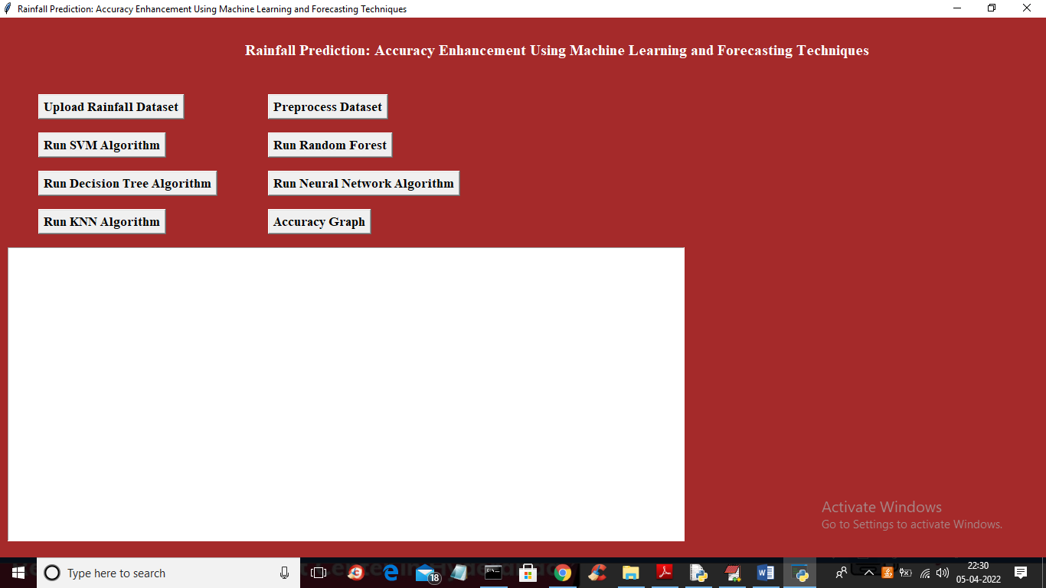
Fig.6.1.Upload Rainfall dataset
In above screen click on ‘Upload Rainfall Dataset’ button to upload dataset to application and get below output

Fig.6.2. Select and upload Rainfall.csv
In above screen selecting and uploading ‘Rainfall.csv’ file and then click on ‘Open’ button to load dataset and to get below output
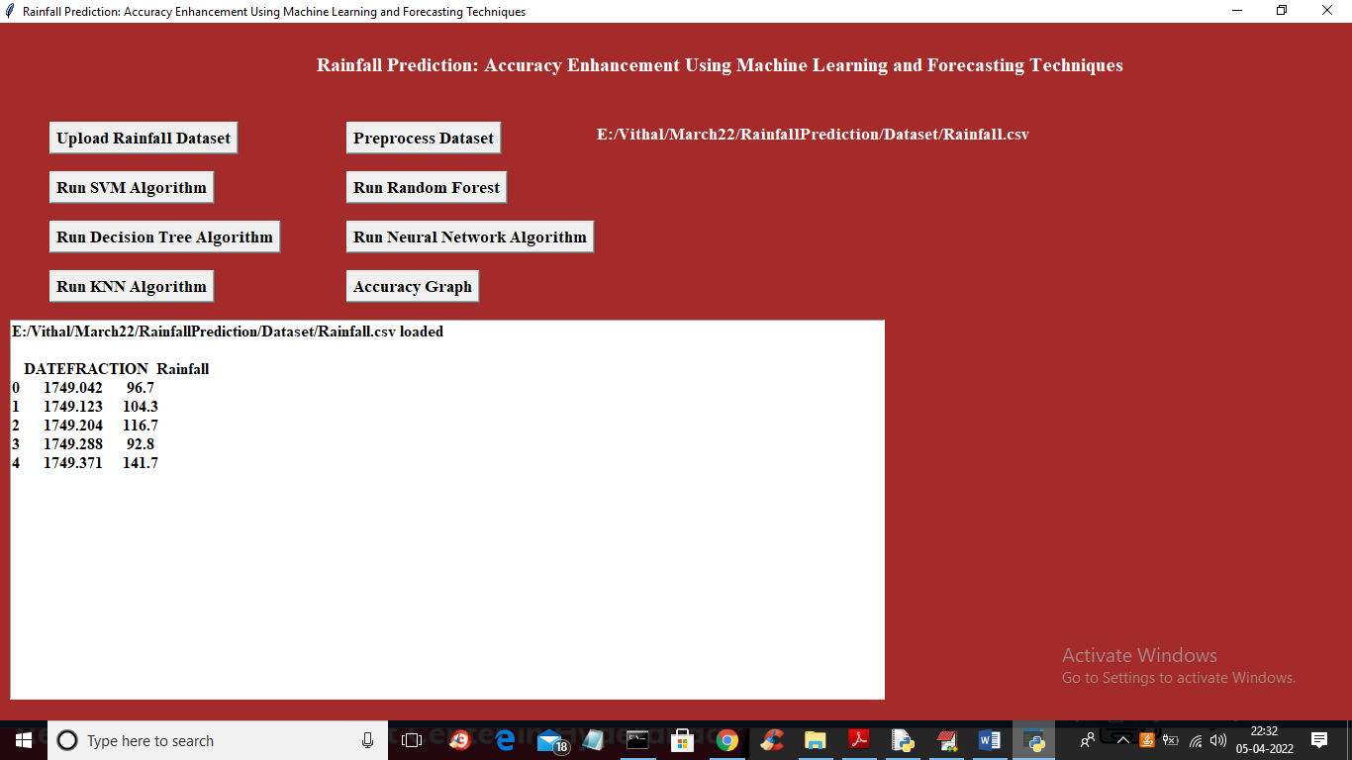
Fig.6.3. Pre-process dataset
In above screen dataset loaded and now click on ‘Preprocess Dataset’ button to read, normalize and split dataset into train and test
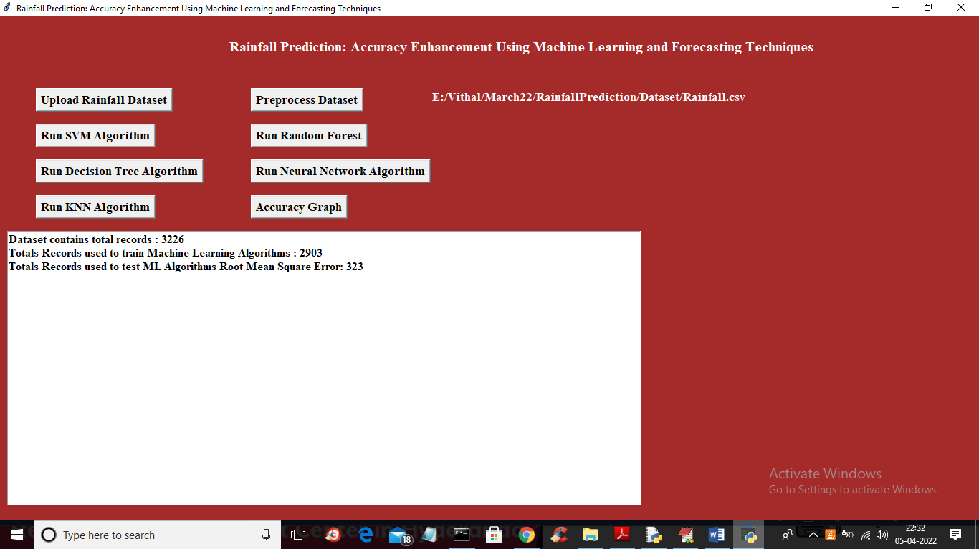
Fig.6.4. Dataset contains records
In above screen we can see dataset contains 3226 records and application using 80% (2903) records for training and 20% (323) records for testing and now dataset is ready and now click on ‘Train SVM Algorithm’ button to train SVM and get below prediction output
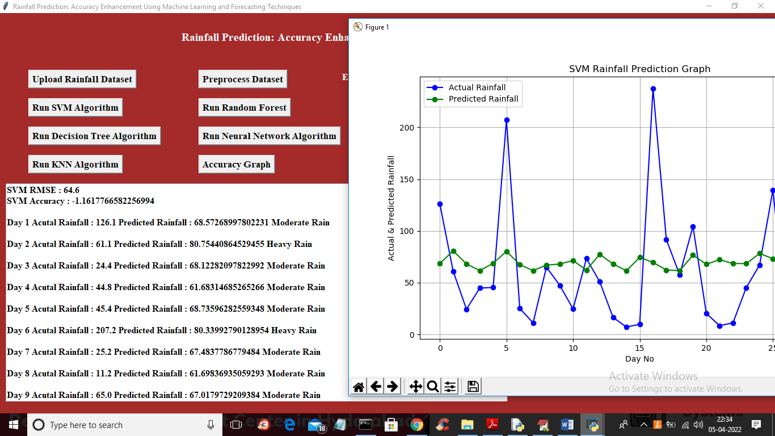
Fig.6.5.SVM accuracy and RMSE values
In above screen in first 2 lines displaying SVM accuracy and RMSE values and then displaying 30 days rain prediction as heavy or etc and in graph x-axis represents DAYS and y-axis represents predicted rainfall and blue line represents test rainfall data and green line represents predicted rainfall and we can see there is huge difference in blue and green line so SVM is not giving better prediction and now close above graph and then click on ‘Run Random Forest’ button to train Random Forest and get below output
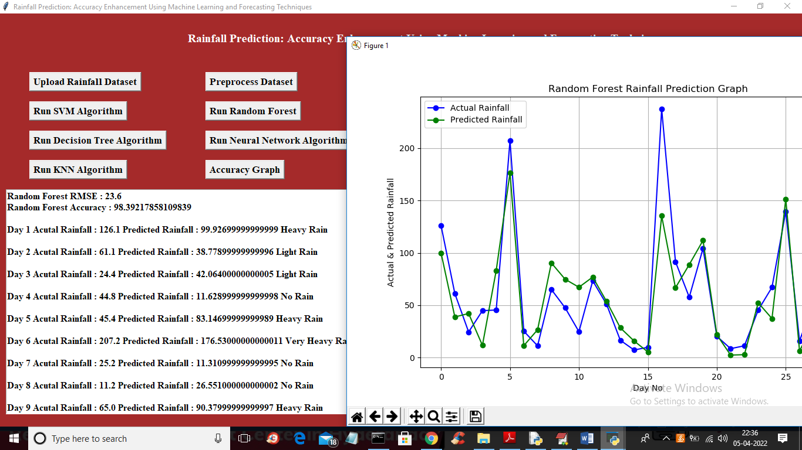
Fig.6.6. Accuracy 98% and performance of Random forest
In above screen with Random Forest we got 98% accuracy and in graph both lines are overlapping so test values and predicted values are accurate and random forest performance is good and now close above graph and then click on ‘Run Decision Tree’ button to train decision tree and get below output
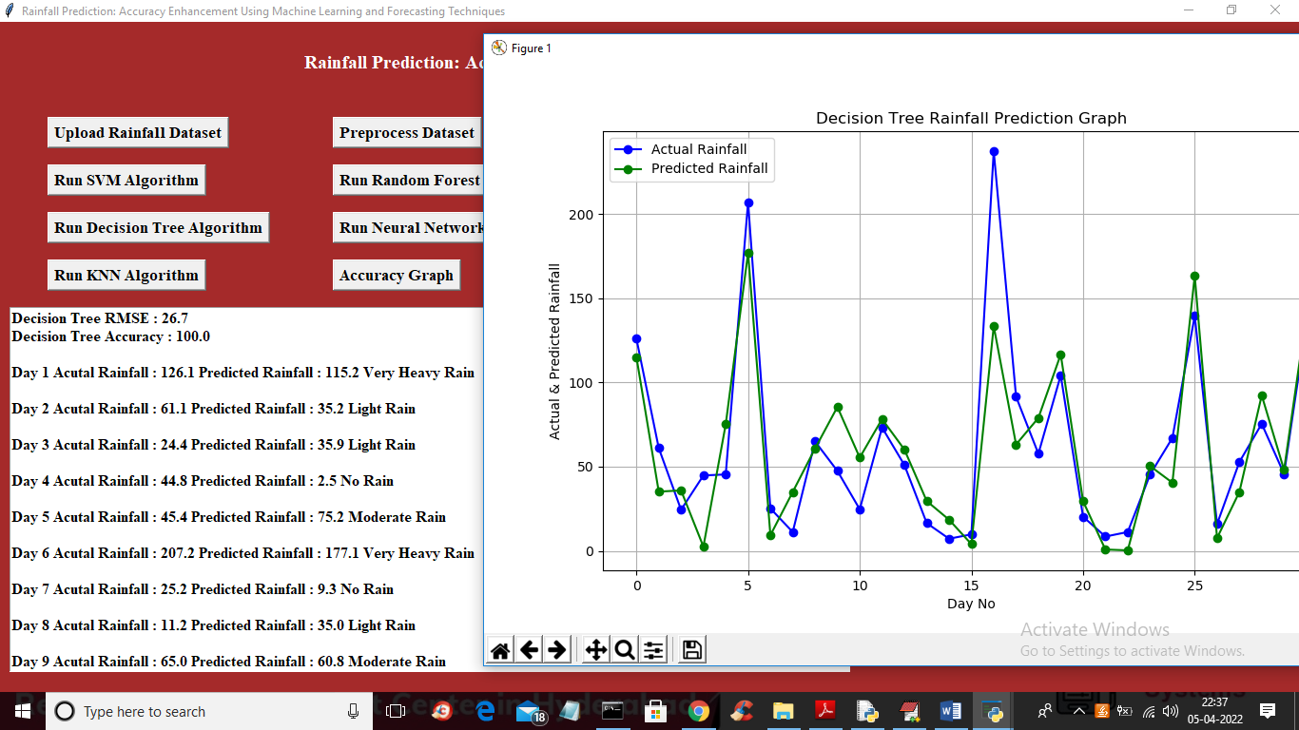
Fig.6.7. Accuracy 100 % and performance of Random forest
In above screen with Random forest we got 100% accuracy and in graph both lines are overlapping so decision tree performance also good and now close above graph and then click on ‘Run Neural Network’ button to get below output
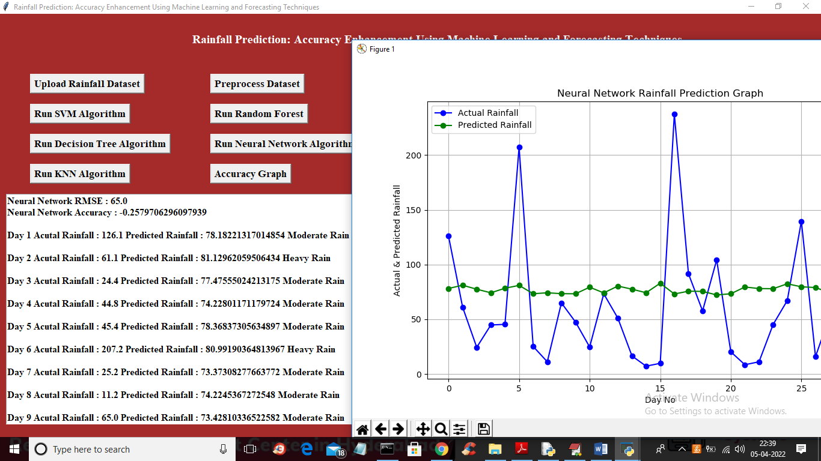
Fig.6.8.Performance of neural network
In above screen we can see Neural Network performance also not good and now click on ‘Run KNN Algorithm’ button to get below output.
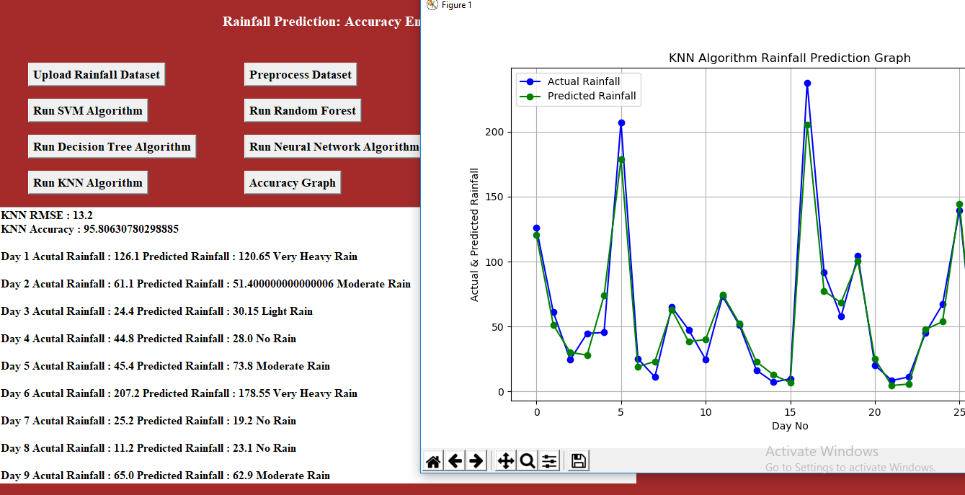
Fig.6.9.Accuracy 95% and performance of KNN
In above screen with KNN we got 95% accuracy and both lines are overlapping so KNN performance is also good and now click on ‘Accuracy Graph’ button to get below graph
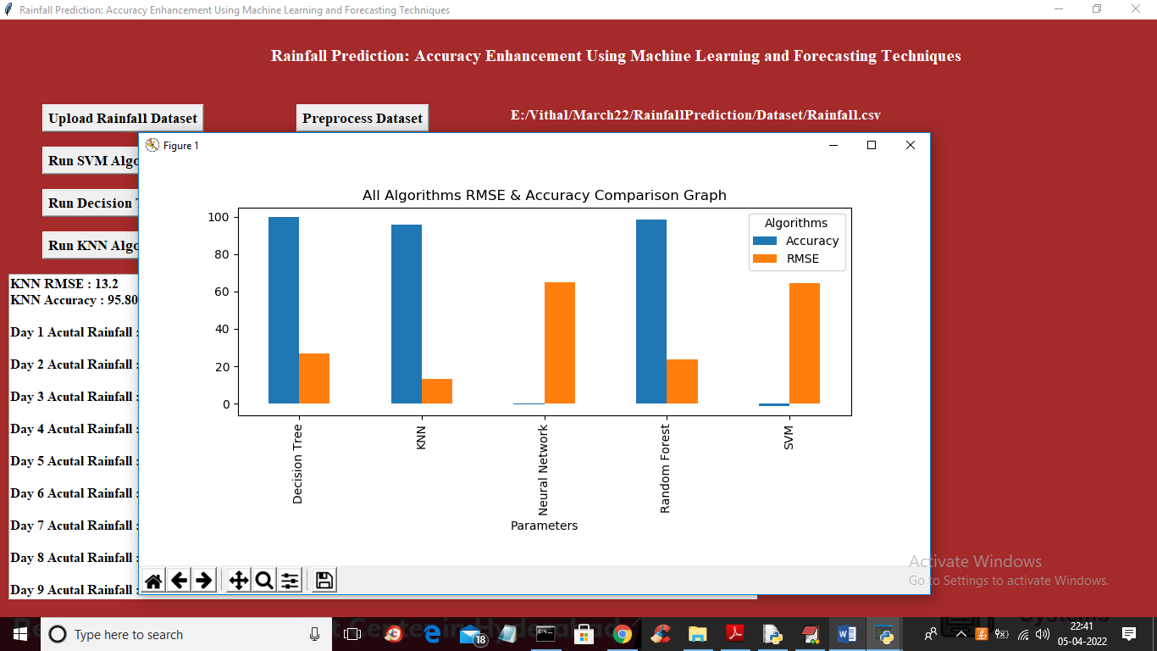
Fig.6.10. Accuracy graph
In above graph x-axis represents algorithm name and y-axis represents accuracy and RMSE values and blue bar indicates accuracy and orange bar indicates RMSE and in all algorithms Decision Tree and Random Forest gave high accuracy and outperform other algorithms

CONCLUSION:
The proposed work is an attempt to forecast rainfall using a fusion of different machine learning and forecasting techniques. Even though the rainfall is dependent on many parameters, we are able to get impressive classification accuracy using limited parameters. It is also found that even after classifying rainfall into eight different categories, we are getting acceptable accuracy. Validations for forecasted parameters are done using RMSE measure. Empirical results show ARIMA for maximum temperature, Neural Network for minimum temperature and SVR for relative humidity and wind speed works best.
Validation of classification is measured through accuracy, precision and recall. ROC curve for all classifiers shows random forest works best for rainfall classification. As rainfall is dependent on the various parameters it is also required to study how other meteorological parameters affect the Rainfall prediction. We can also perform the same exercise on hourly data using various parameters to forecast next hour rainfall. A study can also be done using more observations for particular region or area, and design this kind of model on big data framework so that computation can be faster with higher accuracy.

REFERENCES:
[1] Mithila Sompura Aakash Parmar, Kinjal Mistree. Machine learning techniques for rainfall prediction: A review. International Conference on Innovations in informa-tion Embedded and Communication Systems, 2017.
[2] Nishchala C Barde and Mrunalinee Patole. Classification and forecasting of weather using ann, k-nn and na•ve bayes algorithms.
[3] Debasish Basak, Srimanta Pal, and Dipak Chandra Patranabis. Support vector regression. Neural Information Processing-Letters and Reviews, 11(10):203{224, 2007.
[4] Leo Breiman. Random forests. Machine learning, 45(1):5{32, 2001.
[5] KK Chowdari, R Girisha, and KC Gouda. A study of rainfall over india using data mining. In Emerging Research in Electronics, Computer Science and Technology (ICERECT), 2015 International Conference on, pages 44{47. IEEE, 2015.
[6] Pinky Saikia Dutta and Hitesh Tahbilder. Prediction of rainfall using data mining technique over assam. IJCSE, 5(2):85{90, 2014.
[7] G Gregoire. Multiple linear regression. European Astronomical Society Publications Series, 66:45{72, 2014.
[8] Mina Mahbub Hossain and Sayedul Anam. Identifying the dependency pattern of daily rainfall of dhaka station in bangladesh using markov chain and logistic regression model. 2012.
[9] Rob J Hyndman. Moving averages. In International Encyclopedia of Statistical Science, pages 866{869. Springer, 2011.
[10] Rob J Hyndman and George Athanasopoulos. Forecasting: principles and practice. OTexts, 2014.
[11] Lily Ingsrisawang, Supawadee Ingsriswang, Saisuda Somchit, Prasert Aung-suratana, and Warawut Khantiyanan. Machine learning techniques for short-term rain forecasting system in the northeastern part of thailand. Machine Learning, 887:5358, 2008.
[12] Soo-Yeon Ji, Sharad Sharma, Byunggu Yu, and Dong Hyun Jeong. Designing a rule-based hourly rainfall prediction model. In Information Reuse and Integration (IRI), 2012 IEEE 13th International Conference on, pages 303{308. IEEE, 2012.
[13] Dinu John and BB Meshram. A data mining approach for monsoon prediction using satellite image data. International Journal of Computer Science & Communication Networks, 2(3), 2012.
[14] Jyothis Joseph and TK Ratheesh. Rainfall prediction using data mining techniques. International Journal of Computer Applications, 83(8), 2013.
[15] Sarah N Kohail and Alaa M El-Halees. Implementation of data mining techniques for meteorological data analysis. Intl. Journal of Information and Communication Technology Research (JICT), 1(3), 2011.
[16] Folorunsho Olaiya and Adesesan Barnabas Adeyemo. Application of data mining techniques in weather prediction and climate change studies. International Journal of Information Engineering and Electronic Business, 4(1):51, 2012.
[17] Elia Georgiana Petre. A decision tree for weather prediction. BULETINUL UniversitaNii Petrol{Gaze din Ploiesti, pages 77{82, 2009.
[18] Narasimha Prasad, Prudhvi Kumar, and Naidu Mm. An approach to prediction of precipitation using gini index in sliq decision tree. In Intelligent Systems Modelling & Simulation (ISMS), 2013 4th International Conference on, pages 56{60. IEEE, 2013.
[19] Sirajum Monira Sumi, MFaisal Zaman, and Hideo Hirose. A rainfall forecasting method using machine learning models and its application to the fukuoka city case.

Appendix
A. Python
Python is most popular language. It released in 1991 by Guido van Rossum. In different Platforms the python is runs such as Mac, Windows, Raspberry Pi. Python has a simple syntax and it is same as the English language. While comparing the other language with the python it observed that it requires a fewer line. It is an interpreter-based language it means that code can be executed as soon as it written. That means that prototyping can be accomplished quickly.
For all platform the python is extensive and interpreter standard library are free for the use and distribute in a binary form. It is simple, easy to learn and lowering programmed maintenance. It is an interpreted programming, object-oriented language. Python combines incredible power with extremely simple syntax. Exceptions, modules and very high dynamic data types, classes are included. It supports a variety of programing paradigms other than object-oriented programming, including functional and procedural programming. For programmed python can also use as an external language that require a programable interface.

- Python GUI (Tkinter)
Python provides a various GUI (Graphical User Interface) development option. For all the GUI methods the Tkinter is a most commonly used. To the Python supplied Tk GUI toolkit, the standard python interface. To create the applications of GUI Python with tkinter is a most straightforward and quickest way. To create a GUI using tkinter is a simple task. The standard library of python is Tkinter. To create the GUI application Python provides an easy and quick way when it combined with the Tkinter. For the Tk GUI toolkit, Tkinter is an object-oriented interface.
It is easy to create a GUI application with the Tkinter. The following are the steps,
    - Install the Tkinter module
    - Make main window of the GUI application
    - To the GUI application add one or more of the widgets listed above.
    - Put the main event loop to respond to each user triggered event.

Python has a GUI framework, but Tkinter is the only framework that built into the python standard library. In the python Tkinter is standard library. Tcl is a scripting language which is commonly used in the GUI development, prototyping and testing. Tk is an open source, cross-platform widget toolkit which is used to create GUI programmes by many various programming languages.

- Libraries Used
Pandas:
For the Python programming language pandas is a software library for a data analysis and manipulation. In particular for manipulating, it offers an operation and data structure for time series and numerical tables. It is free software released under the 3 clause BSD license. It is popular open source of python is used int machine learning and data analysis.
NumPy:
NumPy is a python library for the matrices, multi-dimensional arrays and large that adds a large collection of high-level mathematical functions to operate these arrays. For manipulating NumPy is a python library. It also the includes the different functions for working with matrices, linear algebra and Fourier transform.
Matplotlib:
Matplotlib was first introduced in 2002 by John Hunter. It is a fantastic Python visualization library for the 2D array plot. It is multi-platform data visualization library which is based on designed to work and arrays with the SciPy stack as a whole. It provides an open-source alternative to MATLAB. Matplotlib is a graphical plotting and visualization library for Python and its extension that is cross platform.
Scikit-learn:
Scikit-learn is pythons most robust and useful machine learning library. For statistical modelling and machine learning it offers a set of efficient tools such as regression, dimensionality reduction, classification, and cluttering via python interface. It is an essential component of JP Morgan’s Python machine learning toolkit. It is used throughout the band for the purpose of the predictive analysis, classification and variety of the other machine learning tasks.
XG-Boost:
XG-Boost is an open-source software library. For regularizing gradient boosting in Java, python, R, Scala, Perl, C++, XG-Boost provides a framework. It is compatible with Windows, Linux and macOS. In these day XG-Boost is a one of the popular learning algorithms.
Tensor Flow:
Tensor Flow is an open source and free artificial intelligence and machine learning software library. It is used for a variety of the tasks but it focuses on the deep neural network training and interface. Google created and released Tensor Flow, a Python library for the fast numerical computing.

Keras:
Google’s Keras is a high-level deep learning API for the implementing neural networks. It is written in Python and is used to make neural network implementation simple. It also allows for the computation of different neural networks. Keras is open source and free python library for evaluating and developing deep learning models.
h5py:
The h5py Python package provides an interface to the HDF5 binary data format. It allows you to store enormous amounts of numerical data and easily manipulate that data using the NumPy library. It employs simple NumPy and Python metaphors such as NumPy and dictionary array syntax.

